Iteration 1 - Group 17 Part 4

Due Wednesday, September 20th at 1pm. Section 004

Product Goal:

To create a full-service hub for immigrants to perform all their communication with USCIS. Services include requesting immigration status, sending documents to the system for approval, requesting original documents, attending interviews, and getting updates on upcoming steps and document status.

Non-Functional Requirements:

|  |  |  |  |
| --- | --- | --- | --- |
| Num | | Non-functional Requirement | How/whether it was met |
| 1 | The system shall have a response time of 6 seconds | |  |
| 2 | The system shall verify form box entries within 3 seconds of clicking out of box | |  |
| 3 | The request shall be approved or denied within 1-2 days | |  |
| 4 | The request shall be processed for delivery within 1-3 days | |  |
| 5 | Documents shall deliver within a week | |  |
| 6 | Document receival confirmation shall update system within a day of completion | |  |

Functional Req: // States in iteration clarification should be more like data validations so can combine.

* User shall initialize a request for Document return.
* System shall validate request form.
* The document shall be looked up in the USCIS database.
* System shall return request form if no original document were found.
* System shall fetch the requested original document.
* System shall create a copy of the original document.
* System shall add the copy of the document to the USCIS database.
* System shall send the original document to the user.
* System shall display document delivery status updates.
* Users shall verify the receival of the original document.
* System shall keep a record of the receipt of original document.

Epic:

For immigrants who wish to reclaim their original documents from the USCIS database, our online original document request form is an intuitive tool that requests and delivers original documents, provides delivery updates, and asks immigrants to verify their receival of the original documents.

**Data Entry Section - Somaya**

Use Case:

The USCIS website will call this module to create a new form for an immigrant logging in. This form will be filled out with active validation then saved into the USCIS database for the next module to manage.

Proto-Persona:

|  |  |
| --- | --- |
| A person with a neck scarf  Description automatically generated“May” | Behaviors   * Works overnight to juggle job tasks and hobby, and family. * Supports family. * Worries about status often. * Feels overwhelmed when receives letter from USCIS * Meets with immigrations lawyer often. |
| Demographics   * Working single mom. * Has residency status from family. * Divorced, 2 kids. * Works a high-level job but with little pay. * Household 60K/yr. | Needs and Goals   * Looking for jobs that pay full time despite lack of permanents residency. * Wants to quit current job due to inequity in pay. * Needs her birth certificate to renew passport. |

Feature Statement:

1. Data Entry:
   1. Feature: Data Entry.
   2. Benefits: initialization, verification, and saving of form data to deliver to next module.
   3. User Acceptance Criteria: shareable, easy to return form to user if data is invalid.

User Story:

1. As an immigrant, I want to get my original document back so that I can resume my work.
2. As an immigrant, I want to access an online request from so that I can fill it out quickly.
3. As an immigrant, I want to get validation messages so that I can know I am entering the correct information needed for the form.
4. As an immigrant, I want to get a “form saved” notification from the system so that I know that my form was submitted successfully.

User story Map:

**Review Section Starling:**

Use Case:

A request to review a form is sent out from data collections.

Proto Persona:

|  |  |
| --- | --- |
| Barbra Mills | Behaviors   1. Loves hiking and the outdoors. 2. Plans out her next travels. 3. Dedicated to her job. 4. Loves to do puzzles. 5. Makes her own coffee. |
| Demographics   1. 42 years old. 2. Works full time with government. 3. Single. 4. Lives on her own with two dogs. | Needs and Goal   1. Wants to save enough money for an Airstream. 2. Wants to visit all the national parks. |

Feature Statement:

1. Review – Starling:
   1. Feature: Verify that the information is correct.
   2. Benefit: Can check for correct data entry, so time is not wasted on looking for invalid data.
   3. User Acceptance Criteria: accessible, comprehensible returns, checking.

User Story:

1. As a reviewer, I want to be able to accept forms, so that I can review them.
2. As a reviewer, I want to be able to check whether the information on the form is valid, so that I can see what information is not correct.
3. As a reviewer, I want to be able to change the data, so that users do not have to completely redo the form.

User Story Map: Stories labeled by number.

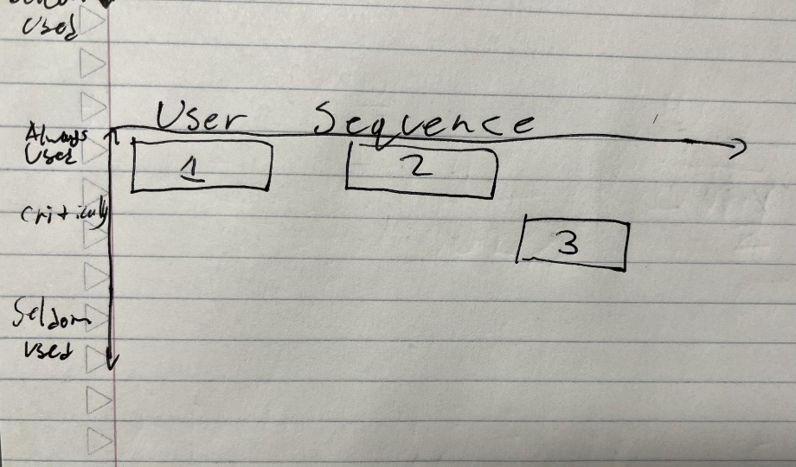

**Approval Section: William O’Brien**



